Somerset Domestic Abuse Strategy 2021-2024

Contents
Chair Foreword 1
Our Principles 2
Introduction 3
The Domestic Abuse Act 2021 3
Somerset’s Domestic Abuse System and Partnership landscape 4
A summary of Domestic Abuse in Somerset - Evidence from the Domestic Abuse Needs Assessment 6
Achievements in the last 2 years 15
Impact of covid 15
Preparing for the Domestic Abuse Act 16
Campaigns and work from last year we want to shout about 16
Family Safeguarding model 17
Priorities for the Somerset Domestic Abuse Board 2021-2024 18
Giving effect to the strategy 21
Next steps and Looking to the future 23
Conclusion 24
References 24

Chair Foreword

As Chairs of the Somerset Domestic Abuse Board and Safer Somerset Partnership, we are delighted to launch our new Domestic Abuse Strategy 2021-2024 which we feel is a significantly different and more ambitious than ever before. With new domestic abuse legislation earlier this year, for the first time, there is a single legal definition of domestic abuse; children (0-18 years) are now considered victims in their own right; we must improve and enhance our offers of support, particularly to those residing in safe accommodation; and the rights and protection of survivors through the courts is strengthened. The new and additional duties are many, offering challenges to us locally but also opportunities to improve how we respond and support victims, families, children, and those who cause harm across Somerset.
Our domestic abuse needs assessment tells us that rates of domestic abuse continues to increase but also gives us more insight about who needs our help but may be reluctant to seek it. We need to make sure our services and partner agencies are geared up to be flexible, supporting anyone in need and also targeting key messages and services to encourage people to come forward.
This strategy sets out a number of ambitious priorities which all require significant change in the domestic abuse system. To achieve this, local agencies must work better together, taking equal responsibility and we must work to effectively allocate all available resources to deliver against each priority area. This will involve creating, through the partnership, more early intervention tactics, aiming to prevent domestic abuse whilst investing in a more robust support model for those who require our help to keep them safe and recover effectively.

Cllr Heather Shearer Lucy Macready
Chair of the Safer Somerset Partnership Chair of Somerset Domestic Abuse Board

Our Principles
- Take a public health approach – focus on prevention
- Domestic abuse doesn’t discriminate – so services and options for safe accommodation must be accessible for all who need it.
- Children are victims too; the system must be able to respond to identify young victims and provide them with the right support
- We will work together as agencies and with communities to make Somerset a safe place for victims and families

Introduction
2021 saw the first ever legislation dedicated to domestic abuse in the UK. The Domestic Abuse Act places a series of statutory duties on local authorities and Partnerships. One such duty is to carry out a Domestic Abuse Needs Assessment and locally, Somerset commissioned this jointly, with tier 1 local authorities across Avon and Somerset to determine the level of need for support within relevant safe accommodation in Somerset, as well as across the police force area. This Assessment was conducted in line with National guidance but was also enhanced to consider the needs of all victims, including those who receive support in the community, as well as data relating to other elements of the domestic abuse system, including MARAC, Domestic Homicide Reviews and criminal justice. As well as considering the prevalence of domestic abuse, the Assessment also reflected on best practice for services and intervention and considered potential performance framework options.
The Needs Assessment is used to form the evidence base that lays the foundation for this Strategy which is another obligation set out in the legislation.

The Domestic Abuse Act 2021
The Domestic Abuse Act (2021) seeks to:
- Raise awareness and understanding of the impact of domestic abuse on victims and their families
- Improve the effectiveness of the criminal justice system in providing protection for victims and to bring perpetrators to justice
- Strengthen the support available to victims of abuse by statutory agencies

The Act introduces a number of key changes and points of clarification to assist in an improved response to tackling domestic abuse, including
- Offering a statutory definition of Domestics Abuse
- Clarifying what is deemed as Safe Accommodation and giving local authorities new duties for commissioning and support
- Guidance for housing providers and housing authorities for the provision of safe accommodation
- Require tier 1 authorities to assess the local needs and produce a strategy
- Places Domestic Abuse Partnership Boards on a statutory footing with their own duties
- Offers new tools and powers to assist agencies in keeping victims safe and bringing perpetrators to justice.
The full statutory guidance can be found here

Somerset’s Domestic Abuse System and Partnership landscape
Domestic abuse is a broad agenda. The composition of which is complex and requires continuous monitoring and improvement. From creating an environment for resilient communities who can identify all forms of domestic abuse, taking a zero tolerance approach, the system includes how we respond to victims, families, children and those who cause harm and how they find pathways to abuse free lives. This involves several processes and multi-agency arrangements, as well as legal protocols and commissioning of services. Figure 1 below is an illustration of how the domestic abuse system works.
Figure 1: Somerset’s Domestic Abuse system
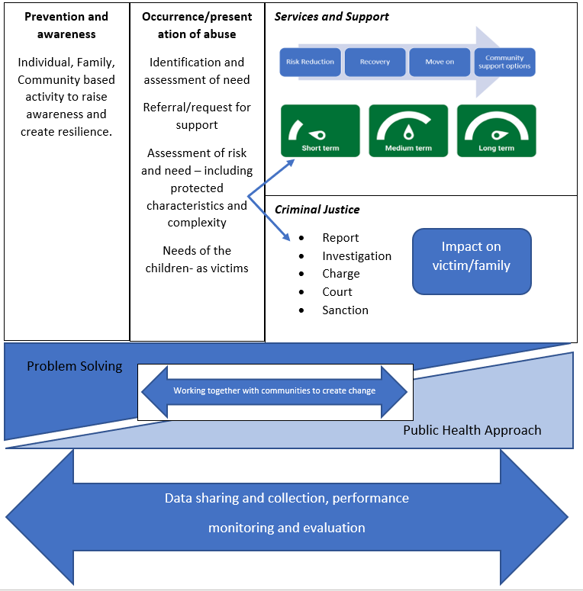
Figure 1

Domestic abuse forms part of the wider community safety agenda which is an ever changing and broad area of work, dependent upon excellent partnership working and collaboration. At this time, all domestic abuse activity is undertaken and discussed under the remit of the Somerset Domestic Abuse Board, which is overseen by the Safer Somerset Partnership. Figure 2 below, presents the full community safety partnership landscape and where domestic abuse fits.
It should be noted that the domestic abuse agenda, spans into the workstream of other strategic Boards, including both of Somerset’s Safeguarding Boards and the Somerset Health and Wellbeing Board. It is therefore vital, that the Domestic Abuse Board and its members, proactively and effectively work across the Partnerships to communicate key messages and gain participation where appropriate to deliver against this strategy and duties arising from the Domestic Abuse Act (2021)
Since the draft Statutory guidance of the Domestic Abuse Act was released, the Domestic Abuse Board has been under development and review to ensure that it meets its statutory obligations. This work is ongoing and revised Terms of Reference can be found in Appendix A.

Figure 2
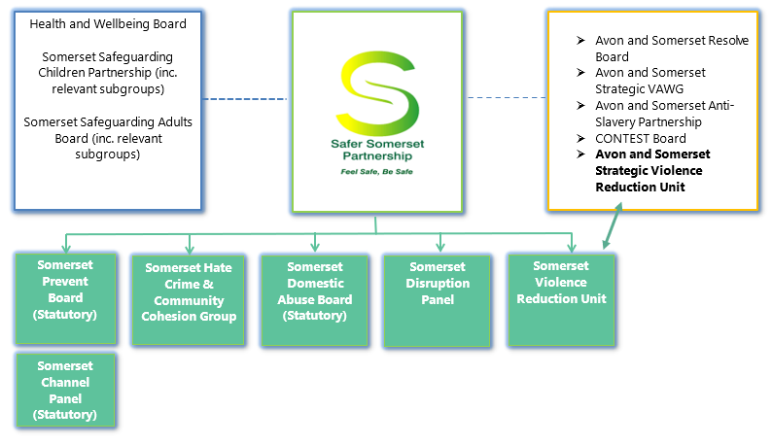

A summary of Domestic Abuse in Somerset - Evidence from the Domestic Abuse Needs Assessment

Prevalence of Domestic Abuse in Somerset
In 2020 the total population in Somerset was 562,108 across the four Local Authority areas.

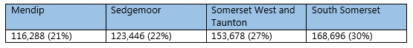

Assessing the number of those over 16, in line with the statutory definition of domestic abuse, it is estimated that around 78,330 will have experienced domestic abuse over their lifetime. On an annual basis, this equates to 23,960 individuals every year who experience domestic abuse (both familial and intimate partner violence). Police data highlights that in Somerset 38.7% of all violent offences are domestic abuse related. Somerset County has the highest number of police reported domestic abuse related incidents and crimes due to the size of the area, but the rate per 10,000 population is lower (12.8) than the regional (13.4) and national (13.5) prevalence rates. Despite the lower prevalence rate domestic abuse crimes actually make up a higher proportion of all crime (20%) than the regional average (17%).

Sexual abuse

Estimated proportion of adults in the south west who have experienced recent rape and/or sexual assault
Males |  |  | Females
Since the age of 16 | Last 12 months | In Childhood | Since the age of 16 | Last 12 months | In Childhood
8.638 | 1,680 | 6,856 | 46,346 | 6,401 | 23,303

The table above presents the prevalence of sexual assault across the South West (Needs Assessment for sexual Assault 2021). According to the CSEW (2015), 19% of women and 3.8% of men reporting domestic abuse experienced sexual abuse. When considering the available prevalence data above, we can estimate that in the last 12 months (of the sexual assault needs assessment) 1,216 women and 64 men had experienced sexual abuse in an intimate relationship. When considering these rates since the age of 16, this increases to 8,806 of women and 328 of men.

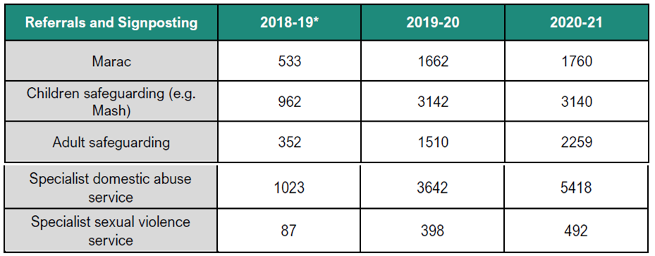
Rates of people in Somerset who require support for current and historic sexual abuse has increased significantly in recent years, with Somerset and Avon Rape and Sexual Assault Service (SARSAS) reporting challenges in demand for their services.

Men
The data suggests that men are underrepresented with an estimated victim prevalence in Somerset of 32%, but
- Only 22% of homelessness applicants where domestic abuse is a primary cause identified as male
- Only 7% of identified victims by primary care were male. There are estimated to be few significant differences by age for male victims, whereas for women aged 16-19 years they’re significantly more likely to be a victim of domestic abuse

Protected characteristics
The Needs assessment uncovered a range of concerns in relation to data, prevalence, and service accessibility for those with protected characteristic in Somerset. Mainly.
- 53% of perpetrators of domestic abuse accessing probation are recorded as having a disability, this is considerably higher than the general population.
- Of domestic abuse perpetrators within the probation service 7% identify as BAME suggests that there is over representation of BAME perpetrators within the criminal justice system compared to the 5% of the general population.
- Around 7% of homelessness applicants where domestic abuse is the primary factor identify as BAME. This is higher than the overall population rate for Somerset in which only 5% are BAME which could suggest out of area applicants are from BAME communities. The Somerset West and Taunton district had the largest proportion of BAME victim/survivors making homeless applications with the majority being Asian or Asian British.
- Victims aged over 61 years are much more likely to experience abuse from an adult family member or current intimate partner than those aged 60 and under. This could have an impact on their safe accommodation needs, particularly where family members of partners have a caring role
- When considering domestic abuse rates and Somerset’s population data, it is estimated that around 32% of victims in Somerset should be male, however, we know that only 5% of all SIDAS referrals were male.
- Several studies have suggested that LGB&T young people and adults are at higher risk of physical, emotional, and sexual violence compared to heterosexual, cisgender people, and Stonewall figures show that 26% of LGBT+ people have received unwanted sexual contact. (SafeLives 2018)
- Teenage victims of domestic abuse research showed that 22% were experiencing sexual abuse such as rape, sexual abuse, unwanted touching or sexual insults. (SafeLives 2015)

Accommodation
The Council of Europe (COE) estimate that one family refuge space is required per 10,000 residents in the community. Based on the number of adults over the age of 16 in Somerset County Council (n=463,227) the total number of refuge spaces required is 46 spaces. Only 35% of this is currently available, and it should be noted that required numbers of accommodation is based on other factors, e.g. demand and national best practice.

The Somerset Integrated Domestic Abuse service (SIDAS) received 147 referrals to their accommodation service during 2020/21 with the majority being from either housing (21%) or self-referrals (22%). There were also a number of referrals (20%) to the safe accommodation service from community based services in the County. More than half (62%) of service users accessing the safe accommodation service are from outside of Somerset County.

Move on from emergency accommodation is considered good, with only 7% of residents remaining in units beyond 3 months. This suggests a good move on process, however, there is also data suggesting that 13% returned to their abuser and 11% returned home with only half of those returning home receiving any form of additional ‘target hardening’ to make their home more safe.

As there are more likely to be mobility and health related considerations for victims aged over 60 years, there is a recommendation in the needs assessment for the safe accommodation offer to be a dispersed model rather than ‘traditional refuge’.

Barriers to people coming forward for help
The needs assessment has identified that there are considerable barriers in Somerset that prevent victims and survivors from disclosing domestic abuse and seeking support. On a positive note, it appears that 43% of victims had contacted the police, which is significantly higher than the national average of 18% according to the Crime Survey for England and Wales (CSEW).
Aside from the police, the most common sector a victim would disclose their experience to was.
• GP (43%)
• Mental health (29%)
• Employer (29%)
This highlights the significant role that health services play in the pathway to support for victims and survivors.

Despite some victims and survivors disclosing to professionals, 36% would not tell anyone making it the second most common outcome. The most commonly experienced barriers for victims were:
• Thought I might be judged or blamed (57%)
• Felt too ashamed or embarrassed (57%)

This was followed by 50% stating they were worried they would not be believed, taken seriously or did not realise their experience was abuse. This is a key learning point as victims will not access the support they need if they have barriers relating to stigma and shame which prevent them discussing their experience.

There may be barriers for victims in accessing local authority homelessness services. As data from homelessness services compared to the needs assessment prevalence suggests that only 1% of victims of domestic abuse in Somerset present as homeless to the Local Authority. This suggests that victims, when wanting safe accommodation, achieve this through other means, whether that be friends, family, private rented sector, etc. Or that they don’t and remain in their home where the abuse continues.

Additionally, financial cost is a barrier for victims to seek and get help. There were very limited older people accessing the existing safe accommodation services, (the majority being aged 25-30 years old). The cost of using refuge accommodation (as many are retired, and are unlikely to be eligible for out of work benefits), means they cannot afford it, Likewise those aged 16-21 access safe accommodation in low numbers, as also have limited benefit options or are in low paid work.

Voice of the Victim: What do victims want from a service?
From those victims participating in primary research in Somerset (n=20), confidentiality is the most important factor in any service or agency response, with 79% of those who responded to our survey highlighting this as the most important element. In addition, the most common answers were.
- a flexible service (64%)
- 24 hour service (57%)
- and a choice between a male or female worker (50%).
- mental health support (71%)
- legal support (43%)
- relationship support (43%).

Those who cause Harm

Although the sanction detection rate for Somerset is higher than other Local Authority areas, the majority of perpetrators are still not being held accountable through the criminal justice system. Only 35% of domestic abuse reported to the police ends in a perpetrator being arrested, and only 10% result in a charging decision.

We know through probation data that perpetrators in Somerset have a wide range of needs, the most common being around problematic substance use, but most commonly alcohol which was a support need for 70% of perpetrators. Drug use was also high with 55% requiring support.
Despite the high level of complexity only 5% of probation identified DA perpetrators are subject to Integrated Offender Management (IOM) which could be a missed opportunity.

Another finding of the Assessment was the need for perpetrators to be considered in terms of a whole housing approach. Probation data indicated that 69% of perpetrators had an accommodation criminogenic need and 52% required support around finances. These factors could cause perpetrators to continue contact and attempting to reside with victims as the only option.

In one of our interviews the victim wanted to remain in a relationship with the perpetrator and ideally would have liked support to have been available to him. As this was not readily available, she left the relationship to stay safe. One of the most common support needs victims noted in the survey with 43% of victims stating they would have liked it, was relationship support, which could affirm this finding that some survivors want to remain in the relationship but with support to help the abusive person change. In fact, 29% of those that responded to the survey wanted support for the person that was being harmful to them. This may not indicate that all survivors intend on staying in the relationship, but it does highlight the need for perpetrator management and behavioural change as many victims note post separation abuse and others will have to remain in contact with the perpetrator due to child contact.

Recommendations from the Needs Assessment
- The domestic abuse partnership should work with the office for the police and crime commissioner and police force to gather satisfaction feedback from victims that report to the police to understand how likely they would be to report again.
- Commissioners should explore colocation models with the commissioned service to ensure all health settings, but particularly the GP and mental health services, are able to act as a first point of contact for victims who are most likely to disclose there.
- Commissioners should review the contract monitoring KPI’s to ensure there are clearer health related outcomes measured to continue building pathways between domestic abuse and health.
- Somerset County domestic abuse partnership should work with regional partners to develop a public awareness campaign focussing on improved awareness within the population around the dynamics of domestic abuse, and that non-physical violence is still abuse.
- Public awareness activity around domestic abuse support available in Somerset should include ‘good news’ stories where victims and survivors who have sought help have reported being believed and taken seriously to break down the biggest barriers to help seeking that we have identified.
- Commissioners should ensure domestic abuse service provision directly offers, or has established pathways, with mental health services as this is the highest support need identified throughout the needs assessment. As per the previous recommendation, this could include colocation models.
- Commissioners should adopt a whole family approach to commissioning all domestic abuse victims services as parenting support was identified throughout the needs assessment, and as children also require support and are now seen as direct victims, a joined up adult and child service would be advantageous.
- Domestic abuse services should be developed with clear pathways with the financial, debt and legal sector locally so that survivors have access to meeting their practical economic needs which was a significant support need identified.
- The local partnership should review the current governance structure and membership and ensure that the Board includes representatives from financial, debt and legal sectors and clear working agreements between sectors.
- The domestic abuse partnership should work with Tier 2 Local Authorities to improve data collection around diversity to provide a more accurate picture around who is presenting.
- The domestic abuse partnership should work with Tier 2 Local Authorities to improve data collection around out of area presentations to understand the demographics of the victims and survivors moving in to the county.
- The domestic abuse partnership should work with Tier 2 Local Authorities and the wider local housing sector to develop a whole housing approach. This should include clear options, and support through outreach, for victims and survivors who want to remain in their own home.
- Commissioners must increase the number of units available. Currently only 35% of recommended capacity is commissioned. This should be used as a baseline by which to increase the provision closer to 100% of recommended capacity.
- Somerset domestic abuse partnership should work with other regional Local Authorities and Avon and Somerset police to ensure target hardening and the use of protective orders such as DVPN/O’s are included within local data collection dashboards. This should include the number applied for, demographics of the victim/perpetrator and support and signposting undertaken.
- Somerset domestic abuse partnership should work alongside other regional Local Authorities to develop relationships with social and private landlords across the geographical footprint to develop policies and protocols to support them to keep their tenants experiencing domestic abuse safe in their own home.
- Somerset domestic abuse partnership should conduct journey mapping for male victims that present as homeless to understand the safe accommodation options and pathways in place for them as they are currently underrepresented in services.
- Somerset domestic abuse commissioners through service specifications should consider the use of dispersed self-contained refuge accommodation for male victims to ensure they have access to emergency safe accommodation without impacting on providers ability to offer women-only spaces. These units should be offered alongside a key worker to ensure support is still accessible within this safe accommodation type.
- Commissioners should work with substance use and mental health services locally to ensure pathways of support are available and skilled to work with perpetrators of domestic abuse, including knowledge of the referral pathways in to SIDAS perpetrator provision, given the high level of complex needs identified through the needs assessment.
- Commissioners should explore how domestic abuse service provision could be designed to provide a service for victims and perpetrators who decide to stay in a relationship.
- Somerset domestic abuse partnership should review the outcomes for perpetrators after a DVPN/O has expired to track whether they return to the home or move on.
- Somerset domestic abuse partnership could work with criminal justice organisations to expand the number of perpetrators identified through the IOM cohort to ensure a multi-agency response is available for prolific perpetrators.
- Somerset abuse partnership should review the multi-agency training offer to all professionals to ensure it includes specific content around identifying and supporting older victims of domestic abuse given the considerably higher population.
- Commissioners should consider through service specifications the need for a specialism within domestic abuse services around supporting older adults
- Somerset domestic abuse partnership should continuously audit the data all services collect in relation to the age of victims and perpetrators in order to better assess the local need for the next needs assessment.
- A review or audit of BAME representation within specialist domestic abuse services and homelessness pathways should be further explored to understand the drivers as well as the specific communities and impacts this may have on support needs.

Achievements in the last 2 years

Impact of covid
At the beginning of the covid-19 pandemic, Somerset’s rates of reporting did not reflect the significant increase that was reported nationally. An early assessment of countries already lived through a pandemic (such as Africa’s experience of Ebola) as well as countries who had begun covid-19 restrictions before England, suggested that rates of domestic abuse could in fact decrease under lockdown restriction due to lack of opportunity to report, the environment not being conducive to victims feeling able and ready to report whilst in general, the ‘stay at home’ restrictions might create an environment that will cause more domestic abuse. For this reason, the priority was to a) ensure that our communities understood what domestic abuse was, that services were open and ready to support and b) ensure our services were able to respond.
Somerset County Council commissioned a multi-media publicity campaign “No Closed Doors 2020” to help ensure the public know services were still available and how to contact them (#NoClosedDoors2020 media centre(somersetsurvivors.org.uk)).
In addition, to help reduce the impact of changes to working practices due to covid-19 restrictions, additional financial resources were given to SIDAS by Somerset County Council and central Government for increased staffing levels.
Somerset developed a framework for its response to domestic abuse overseen by a multi-agency domestic abuse covid-19 task group. The group monitors a comprehensive data scorecard to ensure that the impact of covid is closely monitored and any changes in service demand is known at the earliest possible opportunity. Since April 2020, a multi-agency group has met regularly and has excellent participation from many voluntary and statutory agencies including housing providers, Citizens Advice, women’s charities, NHS, and police. The group has increased collaboration to improve multi-agency response to victims of domestic abuse. This covid-19 task group has found that for many agencies there has not been any sustained increase in service demand.

Preparing for the Domestic Abuse Act
In the autumn of 2020, Somerset County Council as tier one authority received £50,000 funding from the Department of Levelling up, Housing and Communities (formally known as the Ministry of Housing Communities and Local Government) to prepare for the implementation of the Domestic Abuse Act. With these funds, the council:
- Appointed a consultant to complete service mapping, to help determine the variety of services in Somerset who can and do respond to domestic abuse.
- Commissioned a digital learning development company to create a suite of online domestic abuse modules for both public and professionals.
Additionally, Somerset County Council convened workshops with multi-agency partners, including Tier 2 authorities and statutory and voluntary sector representatives. The purpose of these being to help develop a common understanding of the impending new statutory duties, and plan how services may need to adapt and where gap in provision may exist.
A project plan and risk register were established, and a new “Project Change and Improvement Officer” was appointed by Somerset County Council to oversee the implementation of the Domestic Abuse Act. With the “Safe Accommodation Funding” given to the Council by central Government, a proposed new operating model for delivery of safe accommodation was developed by the Council’s Public Health team (as commissioners of “SIDAS”).
The existing Somerset Domestic Abuse Board was reviewed to meet the requirements of having a “Domestic Abuse Local Partnership Board” as specified in the Domestic Abuse Act 2021. Additionally, a “Commissioning” subgroup of this Board has been established, to assist Somerset County Council with collaboration and advice.

Campaigns and work from last year we want to shout about
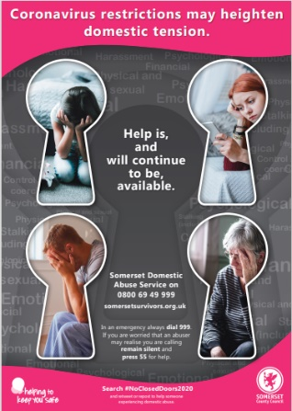
As mentioned in the “impact of covid” section above, Somerset County Council commissioned a multi-media campaign under the heading of “No Closed Doors”. This was to respond to the increased risks of domestic violence and abuse faced by Somerset’s communities due to the Covid-19 pandemic. With the aim of raising awareness of what domestic abuse is and that local help is available, will help keep children and families safer by enabling them to seek support. Appendix B provides an evaluation of some of this publicity activity.

Domestic abuse is also a priority for Somerset’s Violence Reduction Unit. This led to funding been identified to develop a Healthy Relationships campaign aimed at raising awareness on spotting the signs of unhealthy relationships amongst teenagers. The campaign ran during winter 2020/21 and was primarily online and included development of short animated films which gathered tens of thousands of views.
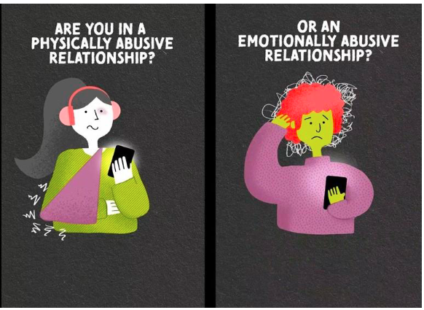 | 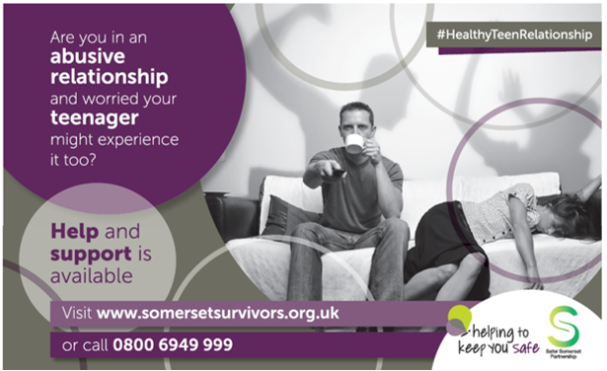

Family Safeguarding model
Family Safeguarding is a whole system reform of child protection services. Family Safeguarding aims to keep more children who are at risk of abuse and neglect safely within their families, by identifying and meeting need. Rather than focusing on identifying risk, multi-disciplinary teams, using motivational practice, work on addressing the compounding factors known as the ‘trio of vulnerabilities’ that are known to cause harm to children. These are domestic abuse, parental substance misuse (drugs and alcohol) and parental mental health.
Family Safeguarding aims to:
- Keep more high-risk families together safely.
- Improve health and education outcomes for children and reduce physical and emotional harm in families.
- Increase engagement with families, thereby increasing the help they receive.
- Strengthen information sharing and shared decision making to better protect children and reduce harm to parents.
- Provide high quality services at lower cost.
As part of the family safeguarding model, domestic abuse practitioners have been carrying out interventions with families as part of the wrap-around support. As of September, 136 families had received support and Somerset County Council is very proud to be one of the first Local Authorities to be working in this innovative way.

Priorities for the Somerset Domestic Abuse Board 2021-2024

Priority 1 | Supporting Survivors and families to access safe accommodation and support as set out in Part 4 of the Domestic Abuse Act (2021)
Description | Plan and Implement a Safe Accommodation offer that makes available relevant safe accommodation support services that meet the needs of all victims who share protected characteristic(s) under the Equality Act 2010 or who share a vulnerability requiring additional support.
How we will meet this objective | Devise and implement a phased accommodation strategy which will  - see an increase in the range and number of units, with a flexible approach. This includes services for children.  - Include a Somerset Sanctuary scheme to make it possible for victims to voluntarily remain in their homes without fear and reduce the risk of homelessness.  - meet the needs of all who need them, including those with protected characteristics and complex needs. This includes victims with No Recourse to Public Funds.  - Consider the support pathways and accommodation needs of those who cause harm and the impact on the victim and associated family  - Consider innovative schemes such as flexible funding, or guarantor schemes for victims on low income or with debt, as part of a whole housing approach
Objective 2 | Identification, response, disruption, and support for People who cause harm
Description | If those who cause harm are not appropriately dealt with or supported to change their behaviour, there will ALWAYS be victims. Traditionally, services are focussed on changing the behaviour of victims to stop the cycle of abuse and whilst this support should continue, this must be balanced with taking those who cause harm to account and supported when appropriate, to prevent them from causing further abuse.
How we will meet this objective | - Ensuring victims are well informed about keeping safe and assisted to become free from abuse.  - Working in partnership stop perpetrators from causing harm.  - Working in partnership to reduce re-offending (IOM) and supporting them to change their behaviour and recognising their behaviour as abuse.  - Services to be available and to be promoted to support those who cause harm regardless of their complexity and protected characteristic.  - Services to be able to identify and respond to abuse across the various forms i.e. intimate partner, adolescent to parent, abuse amongst family members etc).
Objective 3 | A focus on the prevention of domestic abuse
Description | Domestic Abuse is a form of serious violence, which spreads through society like a disease. It is therefore, preventative and not inevitable. Taking a public health approach, we will use available data to target resources to tackle abuse at the earliest possible stage with primary prevention, whilst balancing this with services to respond and rehabilitate victims. If we focus on prevention, we will reduce the number of victims requiring more intensive support in the future.
How we will meet this objective | - Raise awareness of Domestic Abuse and promote services available in Somerset.  - Roll out Somerset’s Domestic Abuse training programme including public facing programme  - Ensure staff training across all agencies is robust and of a standard agreed as set out in Somerset’s Domestic Abuse Learning Development Framework (appendix C).  - Review Learning Development Framework to make sure sexual abuse is proportionately included in training.  - Work with the Somerset Violence Reduction Unit to support their work with young people and educational establishments, in particular, in their work around Healthy relationships.  - Work with sexual assault services to actively promote their services and raise awareness amongst communities  - Engage the voluntary and community sector to create a resilient community  - Develop a mentoring service to encourage volunteers to develop skills to support survivors in the community
Objective 4 | Create a robust domestic abuse system
Description | Continuous development of the whole domestic abuse system is an ongoing and important element of how we ensure that as a multi-agency Partnership, we are able to do our job effectively and ensure that we are able to evidence that what we do, works.
How we will meet this objective | - Quality assurance of the pathway for victims, children, families, and perpetrators, paying particular attention to pathways for victims of sexual abuse.  - Children are victims in their own right, our services and pathways must reflect this, offering the right support at the right time in the right way.  - Provide a robust and effective MARAC with quality assurance in line with national best practice.  - Embed a comprehensive performance management framework.  - Embed learning from Domestic Homicide Reviews.  - Meet our statutory obligations.  - Ensure that specialist domestic abuse services are able to meet the support needs of victims who have experienced sexual abuse.  - Assurance over the Identification, pathways and services for children who are identified and victims.  - Better recording of demographic information on referral and assessment across all agencies.  - Ensure that specialist domestic abuse services have ongoing robust relationships and pathways with health settings  - Develop communications and campaigns to decrease this stigma across communities to increase disclosures and help seeking.

Objective 5 | Targeted activity for those with protected characteristics
Description | The needs assessment identified gaps in data recording and barriers to accessing services for those with protected characteristics, noting underrepresentation in those accessing services and victims and over representation in the criminal justice system when compared to the general population.
How we will meet this objective | - Service provision must be accessible to everyone, with a focus on flexible entry points to encourage older people to report and access all service elements.  - Housing and homelessness pathways to improve promotion of services for domestic abuse victims and ensure identification and referrals for domestic abuse is of a consistent quality.  - Targeted communication activity to promote available services to men who require support.  - Ensure specialist domestic abuse services implement and promote robust pathways for children and young people who require support and accommodation  - Assurance over the identification, pathways and services for children who are identified and victims.  - Collaboration required with probation to better understand the finding that 53% of perpetrators of domestic abuse accessing probation are recorded as having a disability

Giving effect to the strategy

Tier 1 Local Authorities have been allocated Safe Accommodation funding in order to give effect to the strategic aims of this strategy by commissioning services. In 2021-2022 this totalled £1.04m.
In addition, tier 2 local authorities in Somerset were allocated approximately £32,000 each, to assist the tier 1 authority in meeting these burdens.
This fund is issued under the New Burden Doctrine and as such, recurring funding is expected. However, the final annual amount has yet to be determined.
The Domestic Abuse Board has a duty to assist the tier 1 Authority in meeting its duties under Section 4 of the legislative guidance.
It is a requirement of this strategy to include a breakdown of the allocation of our spends against the priorities set out in this strategy. The current predicted breakdown is as follows:

Priority | % of Total Budget Allocation
- Supporting Survivors and families to access safe accommodation and support as set out in Part 4 of the Domestic Abuse Act (2021) | The proportion of spends on the accommodation strategy will be top loaded in year 1 and 2 and is dependent on the availability of properties and the decision of whether to lease or purchase property. At this stage, we estimate that the total proportion of spends on this element will be 75%.
- Identification, response, disruption, and support for People who cause harm | Services for those who cause harm are commissioned in a range of ways, meaning that some can be accessed without direct funding. At this stage, we estimate that the total proportion of spends on this element will be 10%.
- A focus on the prevention of domestic abuse | We have invested in developing training resources and campaigns in 2020-2021 which we will utilise during this strategic timeframe. There may also be opportunities to bring in funding to assist with this from other external sources. At this stage, we estimate that the total proportion of spends on this element will be 8%
- Create a robust domestic abuse system | Resource for meeting this priority will be primarily staff time to drive improvement. Financial implications will be minimal at an estimated 2%.

Next steps and Looking to the future
The Domestic Abuse Board will further develop our strategic plan to create a live activity log, featuring SMART targets to ensure that we deliver against the priorities identified in this strategy.
In line with this, a comprehensive performance framework will be devised, based on the recommendation of the Needs Assessment, to ensure that the Domestic Abuse Board is doing what it should, in an evidence based way.
Part of the assessment of needs is to consider opportunities for further collaboration with neighbouring authorities. At this point, we have jointly commissioned the Domestic Abuse Needs Assessment with our colleagues across Avon and Somerset, we also work together to explore systems improvement in line with the Violence Against Women and Girls (VAWG) agenda, but we know there are and will be, more opportunities. Not just in terms of our processes but also, how we support victims in the knowledge that victims and families are likely to move across to neighbouring authorities. To this end, we will look to not only work more closely with local authorities across Avon and Somerset but also, across to Devon and Dorset as a minimum.
Following a Local Government Review of Local authorities in Somerset, work is now ongoing to create a new single Local Authority for Somerset by April 2023. Bringing services, knowledge, and skills together, from tier 1 and tier 2 authorities in Somerset will inevitably bring change and many opportunities to work in a more effective and collegiate way. We will be working to influence this transformation to make sure that the shape of council services works to further improve the domestic abuse system.
With the development of Somerset’s Integrated Care System will come opportunities for collaboration. The Domestic Abuse Board will work to influence strategy and commissioning to ensure services meet the health and social care needs of adults and children who experience domestic abuse as well as those who cause harm. This is particularly important if we are to meet the duties placed upon us in the Domestic Abuse Act 2021 that stipulates, we must ensure there is support specifically for victims with unique and/or complex needs in safe accommodation.
As well as local change, there is national strategic changes afoot that will impact on our local domestic abuse strategy. 2022 will see a new Serious Violence Duty which will have some bearing on how we deliver our domestic abuse duty. This will bring opportunities to align more with the work of Violence Reduction Units and also, improve how we share data and information to prevent and respond to serious violence. Our domestic abuse strategic refresh will take account of any changes or additional burdens that accompany this Duty.

Conclusion
Domestic abuse continues to be a Partnership wide priority in Somerset. Organisations across the County commit significant time and resource to systems in place to support victims, survivors, families, and those who cause harm with a shared ambition to prevent and disrupt this serious violent crime. Despite efforts, domestic abuse continues to be prevalent in our communities, and services in place, whilst working well, are not reaching everyone who needs it or are lacking in capacity and accessibility.
This strategy, together with the Needs Assessment uncovers what the Partnership needs to do to make improvements to assist those who require our help, to come forward in confidence.
We will seek to improve our safe accommodation offer, focus on cohorts of our communities who appear to struggle to access or gain support, improve our response to those who cause harm, allowing them to come forward when the time is right. To do this we need to make sure the whole domestic abuse system for somerset is robust from our ability to prevent abuse in the first place, to the front door to services, pathways, and through to outcomes for service users which must be recorded, monitored and evaluated effectively if we are to continuously improve.

References

https://www.ons.gov.uk/peoplepopulationandcommunity/crimeandjustice/compendium/focusonviolentcrimeandsexualoffences/yearendingmarch2015/chapter4intimatepersonalviolenceandpartnerabuse#prevalence-of-intimate-violence-extent

Needs Assessment for Sexual Abuse and Assault (SAAS) Therapeutic Pathways in the South West (August 2021, Lime Culture)
Davies, D and Associates (2021) Somerset County Council Domestic Abuse Needs Assessment (DRAFT)

SafeLives (2018) Supporting LGBT+ survivors of sexual violence, https://safelives.org.uk/practice_blog/supporting-lgbt-survivors-sexual-violence
SafeLives (2015) SafeLives Insights Factsheet: Teenage victims of Domestic Abuse. https://safelives.org.uk/sites/default/files/resources/SafeLives%20Insights%20factsheet%20-%20teenage%20victims%20of%20domestic%20abuse.pdf

Appendices
Appendix A Domestic Abuse Board Terms of Reference
Appendix B Communications campaigns evaluations
Appendix C Learning Development Framework

Appendix A - Somerset Domestic Abuse Board Terms of Reference
- Purpose and Role

  - The Local Domestic Abuse Partnership Board is a partnership group responsible for supporting Somerset County Council in meeting its duty under Part 4 of the Domestic Abuse Act.

  - The Board will work together to support, advise, and work in partnership with Somerset County Council to ensure victims of domestic abuse have access to adequate and appropriate support within relevant safe accommodation services. The Board will establish an equitable partnership that reflects the needs of those impacted by domestic abuse in the local area and works to ensure victims of domestic abuse have access to appropriate and specialist support within relevant safe accommodation services.

  - The Board will work together to improve outcomes for victims of domestic abuse, including their children, through a strategic approach to identifying and addressing gaps in support within relevant safe accommodation services.

  - This group is the statutory Domestic Abuse Local Partnership Board as required by the Domestic Abuse Act (DAA) of England and Wales (2020).

2 Frequency
2.1 The Board will meet on a quarterly basis.
3 Membership
3.1 The Board is made up of a number of responsible bodies and agencies that by law, must be represented. These are as listed in the table below. See 3.2 below for information about sector representation. Also 3.3 describes the membership application process.

Sector (as required by DA Act) | Agency/Service | Who | DHR Advisor?
Relevant Local Authority (a) | Somerset County Council (Community Safety/ Public Health) | Service Manager
Relevant Local Authority (a) | Somerset County Council (Community Safety/ Public Health) | Senior Commissioning Officer (Interpersonal Violence) | Yes
Interests of Local Authorities for Areas Within Area (b) | Somerset Strategic Housing Group  + Mendip DC  + Sedgemoor DC  + South Somerset DC  + SWATC | Sedgemoor DC (Domestic Abuse Lead on SSHG)  & Community Safety/DA leads | Yes
Interests of Victims of DA (c) | TBC
Children of DA Victims (d) | Somerset County Council (Children’s Social Care) | Strategic Manager (Operations) | Yes
Charities and voluntary organisations working with victims of DA (e) | Somerset Domestic Abuse Services | Area Manager | Yes
Charities and voluntary organisations working with victims of DA (e) | SARSAS (Somerset and Avon Rape and Sexual Abuse Support) | Director
Charities and voluntary organisations working with victims of DA (e) | SDAS (Somerset Drug & Alcohol Service) | Senior Operations Manager | Yes
Charities and voluntary organisations working with victims of DA (e) | The Nelson Trust | Head of Women’s Community Services
Healthcare services (f) | Somerset Clinical Commissioning Group | Lead for Safeguarding Children & DA | Yes
Healthcare services (f) | Somerset Clinical Commissioning Group | Lead for Safeguarding Adults & DA | Yes
Healthcare services (f) | Somerset NHS Foundation Trust | Lead for Safeguarding Adults | Yes
Healthcare services (f) | Somerset NHS Foundation Trust | Named Nurse for Safeguarding Children | Yes
Healthcare services (f) | Yeovil District Hospital NHS Foundation Trust | Head of Safeguarding | Yes
Policing and criminal justice (g) | Avon and Somerset Police –  (Lighthouse Safeguarding Unit Southern) | LSU Manager | Yes
Policing and criminal justice (g) | Community Rehabilitation Company (BGSW) | Probation Manager
Policing and criminal justice (g) | Crown Prosecution Service | Area Manager
Policing and criminal justice (g) | National Probation Service | Probation Manager | Yes
Barnardo’s (n/s – see 4.2) | Barnardo’s | Service Manager
Housing (n/s – see 4.2) | Registered Social Landlord (Safeguarding Lead) | LiveWest Housing (Safeguarding Lead)
Ministry of Defence (n/s – see 4.2) | Royal Navy/Royal Marines Welfare (RNAS Yeovilton & 40 Commando) | Manager
Adult Social Care (n/s – see 4.2) | Somerset County Council (Adult Social Care) | Adult Safeguarding | Yes
Children’s Commissioning (n/s – see 4.2) | Somerset County Council (Children’s Commissioning) | Troubled Families Co-Ordinator
Safeguarding Children’s Partnership (n/s – see 4.2) | Somerset Safeguarding Children’s Partnership | Business Manager
Safeguarding Adults Board (n/s – see 4.2) | Somerset Safeguarding Adults Board | SSAB Manager | Yes

3.2 The agencies listed here are considered to best reflect the interests of Somerset in its co-ordinated community response to domestic abuse.
The membership of this group is wider than that stated in the DAA, due to its oversight being wide ranging over the whole system for domestic abuse, including MARAC and perpetrators of domestic abuse. Additionally, the strategic benefits of direct links with Somerset Safeguarding Children Partnership and Somerset Safeguarding Adults Board.
3.3 In accordance with the statutory DAA guidance, other bodies can express an interest in becoming a member of the board. This can be done via email, outlining the agency’s role in tackling domestic abuse and why it does not believe an existing member cannot adequately represent their interests. Requests will be considered by the next Board’s meeting. Emails should be sent to: communitysafetyteam@somerset.gov.uk.

3.4 Chairing
3.4.1 The Board will be chaired by Lucy Macready, Public Health Specialist (Community Safety)
3.4.2 Vice Chair of the Board is Louise White, Service Manager, Safeguarding Operations, Adults & Health.
3.5 Members of the Board are responsible for ensuring they report back and feed into the Board on behalf of their represented group/body.

4 Roles and Responsibilities
4.1 The Board will:
- Provide advice and data to support Somerset County Council to undertake a robust local needs assessment to identify and understand the needs of domestic abuse victims within relevant safe accommodation, in their area (including those that present from out of area).
- Provide expert advice and data to support the development of a local strategy, agreeing the appropriate steps needed to meet the needs identified – ensuring the needs of all victims, including those with protected characteristics and / or additional complex needs, are represented and met through the strategy.
- Support Somerset County Council to effectively engage with domestic abuse victims and expert services in understanding the range and complexity of needs.
- Support Somerset County Council to make commissioning and decommissioning decisions (where appropriate). This can include when and how commissioning is undertaken to ensure the best and most appropriate services are made available for victims.
- Note: local authorities should take into consideration that some Board members may have a conflict of interest. It is advised that domestic abuse relevant safe accommodation service providers should not be involved with local commissioning decisions in relation to this duty.
- Support in ensuring join up across other related areas such as alcohol and drug treatment services, housing, health, early years and childhood support, social services and police and crime services [not limited to]
- Advise and support in dealing with issues raised and identified from engagement through formal and informal routes.
- Provide advice to Somerset County Council about the provision of other local authority domestic abuse support.
- Escalate issues to the relevant representative / body
- The Board will monitor performance and activity from across the local partnership on an at least quarterly basis. This will include:
  - Information from MARACs
  - Data from police / criminal justice agencies
  - Trends/patterns from client data from commissioned services
  - Data from both of Somerset’s Safeguarding Boards where appropriate. For instance, hidden harm, modern slavery, FGM, forced marriage, honour-based violence where collected.
- Each agency is required to report on its actions for tackling domestic abuse and sexual violence against the Board’s 10 Quality Assurance principles as part of an annual self-assessment audit
- Domestic Homicide Reviews (DHR) - The group will assist the Safer Somerset Partnership in meeting its responsibilities for DHRs by:
  - considering cases of suspected domestic homicide via a virtual process and make recommendations to the Safer Somerset Partnership Chair
  - Ensure that all actions are completed
  - Audit of completed action plans
- Multi-Agency Risk Assessment Conferences (MARAC) - The Board will provide oversight and coordination of MARAC activity in Somerset by:
  - Monitoring and assessing the overall performance of the MARAC process in Somerset and ensure they operate in line with the 10 principles of an effective MARAC.
  - Ensure that the MARACs operate in line with legal responsibilities and keeps up to date with changes to legislation and national guidance.
  - Ensure that MARAC meetings are fully attended with appropriate and trained representation.
  - Receiving assurance that effective partnerships are maintained with other public protection bodies and other MARAC areas.
  - Address operational issues.
  - Participate in Safe Lives MARAC Quality Assurance Process as and when necessary.
- Specialist Domestic Violence Courts (SDVC)
  - Receive reports on case volumes, outcomes and consider areas of improvement.
  - Oversee quality in accordance with the 12 components of an effective SDVC.
  - Escalate any issues to the Avon and Somerset Domestic Abuse Strategic Group
  - Crown Prosecution Service representation to link closely with point linking to District Judges and Judges (Crown Courts). Training and development of magistrates and court professionals is key to the success of specialist courts.
- Communications and Promotional Activity
  - The Board will ensure that communication for Domestic Abuse and Sexual Violence in Somerset is clear and consistent, aligning to the Safer Somerset Partnership’s Communications Strategy.
  - The Board will support and commission regular consultation and customer engagement to ensure that the voice of survivors of domestic abuse and sexual violence are heard.
  - The Board will develop a means to test and receive feedback from partners and the public about the effectiveness of communication and messages.
- The Board will facilitate positive communications with local level teams, groups, and services to ensure that operational areas of risk, service gaps and opportunities for improved multi-agency working and useful intelligence can be shared.
- Operational Domestic Abuse partnerships and champions networks will be encouraged to develop at neighbourhood level (e.g. Domestic Abuse Link workers).
- The Board will develop and maintain a virtual partners’ network for information cascade and communication.

4.2 Escalation Process
- Escalate potential risks and concerns relating to implementation of the Domestic Abuse Act duties to the Safer Somerset Partnership and the Avon and Somerset Domestic Abuse Group as appropriate.
- Ensure any operational issues are identified and escalated to this group and upwards as required.

5 Agendas
5.1 Members will be able to put forward suggested agenda items for consideration. The secretariat will circulate final agendas at least 5 days ahead of meetings.
5.2 Standing agenda items will include:
- DA Act Implementation
- MARAC
- Domestic Homicide Reviews
- Performance (across partner agencies)
- Training

6 Absence
6.1 Where members are unable to attend a meeting, they are responsible for informing the Board ahead of the meeting and, as far as possible, should ensure a representative is present on behalf of the organisation / body.
7 Reporting
7.1 The chair / Board will report back to Safer Somerset Partnership on a quarterly basis.

7.2 The Board will support Somerset County Council in reporting back to DLUHC on delivering the duty in line with statutory guidance and the standardised reporting form.

8 Review

8.1 The Terms of Reference and productivity of the group will be reviewed from March 2023.

Appendix B - Somerset County Council Domestic Abuse Campaigns 2020 Evaluation

1 Background

1.1 Somerset County Council (SCC) secured funding from the Somerset Violence Reduction Unit for two domestic abuse campaigns, these were to be ‘staggered’ (and not run concurrently).

These campaigns were commissioned following local domestic homicide reviews (DHRs) recommendations. This is because there’s been no systematic widespread local campaigns and a recurring theme from DHRs is that the public have limited understanding of domestic abuse in all its forms, and do not know how to seek help if they did have concerns. The campaigns were launched under the slogan of #NoClosedDoors2020. The aims of these were to:

- Raise awareness of the pattern of domestically abusive relationships. And how individuals can access support to end this cycle of one abusive relationship after another.
- Help family and friends understand the signs of domestic abuse and what they can do to help. Promote the information/guide at our Somerset webpage http://www.somersetsurvivors.org.uk/support-for-a-friend-or-family-member/

1.2 However, in March 2020, the Covid-19 pandemic arrived. And following significant local, national, and international concern about the impact this would have on domestic abuse victims. SCC funded an additional third campaign aimed at ensuring victims would know they could seek and obtain help.

2 Objectives of the Campaigns

2.1 Awareness raising was the prime objective. So, people have the confidence to take the first steps to freedom from abuse and ensure those around them are able to support. Specifically, a wide range of media were required in order to help:

- Change behaviour and attitudes, by increased understanding of all forms of domestic abuse, including coercive and controlling behaviour (campaigns 1, 2, 3)
- Empower individuals to play their part in tackling the issue (E.g. encourage family, friends to spot the signs and share concerns) (campaigns 2, 3)
- Give confidence to victims to seek help and advice (and help remove their fear) (campaign 1, 3)
- Promote support services in Somerset (campaigns 1, 2, 3)
- Ensure victims in rural communities have access to these campaigns and can seek help (campaigns 1, 3)
- Somerset residents (public and professionals) know that despite Covid-19, local specialist domestic abuse services remained available. (campaign 3)

2.2 The Somerset Domestic Abuse Board at their December 2019 meeting agreed that these campaigns should ensure focus on improving awareness in rural communities.

3 Key Activity

3.1 Pre-Covid-19 (and lockdown)
- The #NoClosedDoors2020 campaign started end February 2020, and prior to the national lockdown 4 weeks later, a total of 6 press releases were published, 1 radio interview and advertisement on 8 local radio stations in the county.
- Visitors to the www.somersetsurvivors.org.uk website were: 1281 (new users) in February/March 2020, compared to 553 in the same period of 2019.
- Social media was utilised to obtain a reach of 49,775 and 2,939 engagement.
- Calls to the local helpline remained virtually the same as in 2019.

  - Covid-19
- The campaign started in May 2020 (when the budget was confirmed) and concludes 31.1.2021. The image below shows at the mid-point in September 2020, the activity:
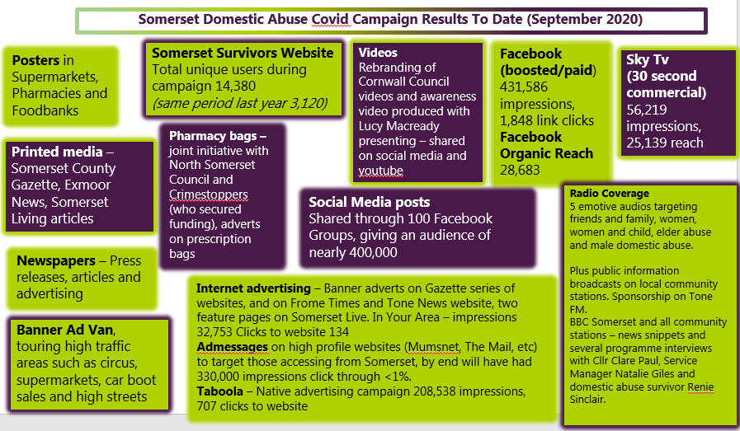
- A variety of marketing activity is planned up to the campaign end in January 2021. This remaining period will also wrap up the remaining activity from pre-covid-19.
Activity will include: social media promotion, press releases, community radio advertising, local community networks (e.g. parish councils), Instream advertising (national digital radio stations Geo- targeted audience) and bespoke Greatest Hits Radio Campaign which will include airtime, a dedicated page on their website which will be cross promoted through direct email on their social media channels and two insertions in their weekly newsletter. There’ll be specific awareness raising regarding male domestic abuse and older people, as recent DHRs have evidenced a need for better public and professional knowledge and understanding of these issues.

4 Impact of Campaign
4.1 As section 3 explains there’s been a wide variety of activity, which has reached tens of thousands of Somerset residents. To date the calls to the domestic abuse helpline and referral numbers have not exceeded the 2019 comparators. Although the national helplines have reported significant increases, as have some local services elsewhere in the country. Of course, we don’t know without the campaigns if the calls to our Somerset helpline would have been even lower.
4.2 This is the first significant marketing campaign Somerset has had. To expect a significant increase in calls and people seeking help would be ambitious.
Especially considering doing so during a pandemic. The impact of restrictions on people’s lives through two national lockdowns, changes to employment practices (i.e. mandatory working from home in many situations, furlough, etc), changes in people’s ability to shop, to partake in leisure activities cannot be underestimated.
4.3 Evaluating behaviour change programmes is not straightforward. For instance, implementing an effective survey for those experiencing domestic abuse (particularly those who’re not in contact with the local domestic abuse service), is problematic due to the sensitivity of the subject.
Also, research over many years has shown that many domestic abuse victims do not seek help immediately on experiencing abuse. For all, it takes significant courage to want to get help, due to a complexity of reasons. Or for many to even realise that what they’re experiencing isn’t right, and they can get advice and support. Changing behaviour and attitudes takes time.
4.4 Therefore it’s difficult to assess an immediate societal impact of the campaign. Numerically we know radio listener figures, social media reach, TV viewing numbers, etc. Given that 1 in 4 women and 1 in 6 men are estimated to experience domestic abuse in their lifetimes, there will have been several thousands of people who the messaging will directly benefit.
4.5 Many of those visiting the website will have been helped simply by having the opportunity to be informed about their situation - a confirmation that what they are experiencing is domestic abuse. In some cases, this may be help enough for them to take their own actions to change their situation and flee abuse.
4.6 Finally, given the many facets of domestic abuse and the need to be targeted in messaging. For example, an advert targeting both male and female victims will not work, nor will combining younger people and older people in one campaign, etc. Different ads and marketing activity are required for the numerous groups. A long-term approach to local domestic abuse campaigns is required.

5 Recommendation

5.1 It’s recommended that domestic abuse campaign activity continues on a permanent basis. To ensure all different types of abuse and different groups (e.g., younger, older, those with children, those without children, LGBT, men, disability, etc) all can be targeted and effectively promoted.
5.2 Many domestic abuse related deaths, whether suicide, murder or alcohol/drug related persist in the county. The need is there for raising awareness with public and professionals.
5.3 Dedicated resource will be required. Both someone to develop marketing campaigns (part-time), and a budget to develop and deliver advertising material.
5.4 The media centre should continue to be utilised by all agencies #NoClosedDoors2020 media centre | Somerset County Council Newsroom (somersetnewsroom.com)

Appendix C – Learning Development Framework
Introduction
This learning framework incorporates national standards; supports local strategic aims and promotes the need for cultural change for agencies who support anyone affected by domestic abuse and sexual violence. It applies to all organisations, professionals and staff in Somerset who do not work to the “Adult Safeguarding: Roles and Competencies for Health Care Staff” or Safeguarding Children and Young People: Roles and Competencies for Healthcare Staff Intercollegiate Documents published by the Royal College of Nursing.
The learning opportunities outlined are based upon minimum standards and what outcomes specific groups of staff should be capable of achieving. The levels of competence those groups of staff should hold remains the responsibility of each organisation to measure with their own performance management and compliance processes. The framework profiles four groups of staff who may have different levels of responsibility to safeguard adults. The lists of job roles within each group provided below is not exhaustive or exclusive to those suggested. Each grouping is a guide and some roles may overlap, and each organisation therefore needs to identify the necessary capability that staff may require in their organisation.
Staff group 1 | Members of this group have a responsibility to contribute to identifying and responding to domestic abuse, but do not have specific organisational responsibility or statutory authority to intervene. Including, but not limited to: All support staff, admin staff, HR staff, health and safety leads and call centre staff.
Staff group 2 | This group have considerable professional and organisational responsibility for identifying and responding to domestic abuse. They must be able to act on concerns and contribute appropriately to local and national policies, legislation and procedures. This group needs to work within multiagency contexts. This group includes, but isn’t limited to: Social care workers, frontline managers, housing officers, substance misuse workers, police, probation, operational and service managers
Staff group 3 | This group is responsible in ensuring their organisation is fully committed to identifying and effectively helping people affected by domestic abuse at all levels and have in place appropriate systems and resources to support this work in an intra and inter agency context.  Including, but not limited to: Somerset Domestic Abuse Board members, safeguarding adult leads, safeguarding children leads, senior managers with responsibility and/or accountability for managing the organisations safeguarding functions.
Staff group 4 | This group is responsible for the overall management of the organisation and/or its governance. Including, but not limited to: Executive and non-executive directors, chief executive officers, elected members, trustees etc.

The Framework
Staff Group | Competency | Examples of potential evidence | Opportunities for Learning
Staff Group 1  Awareness Level  All staff (including volunteers)  Irrespective of role everyone has a responsibility to contribute to identifying and responding to people affected by domestic abuse.  Staff in Group 1 may encounter adults or children but do not have specific organisational responsibility or statutory authority to intervene. | - Know what domestic abuse and sexual violence is.  - Recognise signs of domestic abuse and take relevant action.  - Understand cultural diversity when working with individuals.  - Understand the local domestic abuse and sexual violence process.  - Know about local and organisational policy, procedures, and legislation around domestic abuse relevant to the role.  - Ensure effective administration of domestic abuse processes. | - Able to describe possible signs and indicators of domestic abuse.  - Able to name categories of domestic abuse.  - Able to explain how to handle a disclosure of domestic abuse.  - Able to explain what they should do if they are worried, and who they should tell.  - Able to explain what to do if the named person isn’t available.  - Able to describe boundaries of confidentiality and how information can be appropriately shared.  - Able to demonstrate an awareness of key legislation relating to domestic abuse.  - Able to locate domestic abuse policies relevant to their role.  - Able to clearly record their concerns and know the correct paperwork to use.  - Able to explain the process of reporting a colleague or their organisation if they are worried about practice. | This learning can be provided via eLearning or face to face training and should be covered as part of induction for everyone.  Organisations should consider how often refresher opportunities are available, and what form this should take but should be able to demonstrate that staff and volunteers have up to date knowledge.  Resources  E-Learning – including:  Domestic Abuse awareness (somersetsurvivors.co.uk)
Staff Group 2  Responder Level  In addition to the duties above this group are also:  Includes staff who are in regular direct contact with people who may be experiencing domestic abuse and who may need to raise a concern and/or complete a domestic abuse referral form  They maybe a MARAC representative or Designated Safeguarding Lead within their agency or service | All competencies for Staff Group 1 plus:  - Demonstrate skills and knowledge to contribute effectively to the domestic abuse pathway process  - Manage domestic abuse concerns and enquiries, including working with multi-agency partners  - Ensure people who use services are supported appropriately to understand domestic abuse issues to maximise their decision making  - Understand impact of cultural diversity or other protected characteristic when working with individuals  - Maintain accurate, complete, and up to date records and achieve best evidence. | - Able to respond to concerns raised in a timely manner  - Able to follow and use local pathways and referral processes  - Able to demonstrate knowledge of key legislation relating to domestic abuse.  - Able to maintain accurate, timely records  - Able to develop protective strategies for those who have capacity and decline services  - Able to confidently use whistle blowing procedures and escalation procedures when needed.  - Able to provide information on local and national services that may be able to provide support e.g. IDVA’s, Victim Support  As Domestic Abuse Referrer for their organisation:  - Understand their responsibilities as a referrer when a concern is raised with you or you have become aware that domestic abuse has occurred, or is suspected  - Understand potential decisions which may result from the work they undertake as nominated referrer | At this stage training should normally be face to face and multi-agency. Training should take place as soon as practical after awareness level training is complete (above)  Organisations should consider how often refresher opportunities are available and what form this should take but should be able to demonstrate that staff have up to date knowledge and skills.  Employers should ensure the package used meets the competencies required for Staff group  This staff group and above should have an awareness of Child Protection and Safeguarding Adults arrangements to take a ‘Think Family’ approach.
Staff Group 3  Decision Makers Level  In addition to group 1 and 2 this group is  responsible for ensuring  that the management and delivery of  services to those experiencing harm from and who cause harm related to domestic abuse is effective and  efficient.  They will have  oversight of the  development of systems,  policies and procedures  in accordance with  national, local and  organisational policies  and procedures | All competencies for Staff Groups 1 and 2 plus:  - The provision of training and supervision to develop and promote domestic abuse awareness  - Robust Inter agency and multiagency systems to promote best practice  - Support the development of robust internal systems to provide consistent, high quality services that promotes safety for people affected by domestic abuse  - Ensure record systems are robust and fit for purpose | - Work with partner agencies to develop a consistent approach to responding to domestic abuse  - Awareness of up to date protocols and able to implement them  - Able to challenge poor practice at an intra and inter agency level  - Ensure effective supervision policy and practice in place and used, including escalation procedures utilised when required  - Monitor and audit systems to ensure accuracy and consistency across records and implement learning from audits, to ensure domestic abuse is appropriately recorded  - Ensure domestic abuse policies & practice are in place to support effective risk and decision making in practice  - Ensuring all staff are kept up to date with training and development opportunities in line with their role and responsibilities | At this stage training will normally be face to face and can be single agency or multi agency training. Consideration should be given to the benefits of multi-agency training in building multi agency working  relationships and understanding.  This staff group will need to access to more in depth training on a wide range of themes including (not exhaustive list):  - Coercive control  - Honour Based Abuse  - Forced Marriage  - Stalking  - Victims with protected characteristics  - Responding to perpetrators
Staff Group 4  Organisational Leaders without a direct reasonability/ accountability for safeguarding functions  Irrespective of role everyone has a responsibility to contribute to effective identification and support of people affected by domestic abuse.  Staff in Group 4 are responsible for the governance of the organisation, although unlike group 3 they do not have a direct responsibility and/or accountability for this function and may not be employees of the organisation (for example trustees). | - Know what domestic abuse and sexual violence is.  - Recognise, seek assurance of and where appropriate act on the organisations responsibilities to ensure people are receiving appropriate support  - Understand the organisations need to ensure cultural diversity when working with individuals.  - Understand the local pathways for domestic abuse and sexual violence.  - Ensure effective governance and quality of processes supporting those affected by domestic abuse or sexual violence.  - Ensure that any concerns that are raised about the organisations approach to responding to domestic abuse are addressed transparently | - Able to describe the organisations responsibilities for responding to domestic abuse  - Proactively seeks appropriate assurance that the organisation is meeting its responsibilities.  - Able to describe possible signs of domestic abuse.  - Able to explain how to appropriately respond to a disclosure of abuse.  - Able to describe boundaries of confidentiality and how information can be appropriately shared.  - Able to locate organisational domestic abuse policies.  - Able to describe how the organisation would respond appropriately to a concern about domestic abuse or sexual violence responses and practices, including but not limited to those raised as a result of ‘Whistleblowing’ | This learning should be provided by a mixture of eLearning and bespoke face to face learning that gives individual a chance to explore scenarios that the organisation might encounter and should be covered as part of every individual’s induction.  Organisations should consider how often refresher opportunities are available, and what form this should take but should be able to demonstrate that individuals have up to date knowledge.  Resources  E-Learning – including:  Domestic Abuse awareness (somersetsurvivors.co.uk)

